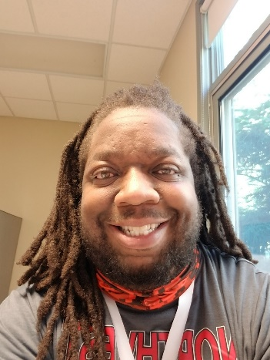
Mr. Christian
Hello, my name is Christian. I have worked here at the Torrant Center for 6 years! I have a wife and 2 lovely children who are identical twins. Some hobbies I enjoy are reading, writing short stories and listening and creating music.

